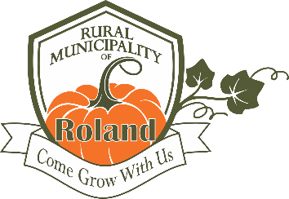
NOTICE OF REGISTRATION
OF PROSPECTIVE CANDIDATE FOR GENERAL MUNICIPAL ELECTION
RURAL MUNICIPALITY OF ROLAND

Please be advised that a general municipal election will be held on October 28, 2026.

Prospective municipal election candidates must register with the Senior Election Official (SEO) during
the registration period before they may begin to accept contributions, incur expenses, fundraise or borrow money for their campaign.

NOTICE IS HEREBY GIVEN that candidate registrations will be received:

For the office of head of council: Between May 1, 2026 and September 22, 2026

For the office of councillor: Between June 30, 2026 and September 22, 2026

at the RM of Roland office, 45 3rd St. in Roland during the regular hours of business, Monday to Friday 8:30a.m. till 12:00p.m. and 1:00p.m. to 4:30p.m.

To obtain a registration form, contact the municipal office at 204-343-2061 or by email to admin@rmofroland.ca

Dated at Roland on April 30, 2026.

Amber Klassen
Senior Election Official (S.E.O.)
Rural Municipality of Roland
Box 119 Roland MB R0G 1T0
Phone: 343-2061
Email: admin@rmofroland.ca

